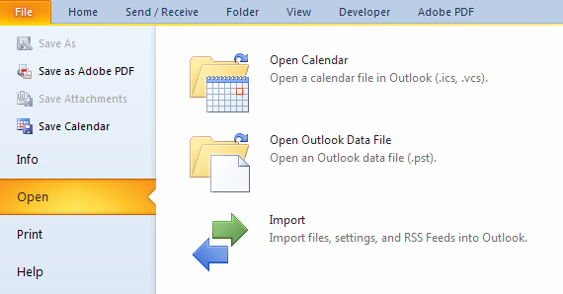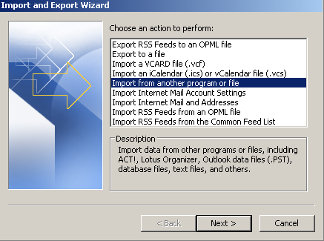

**Importing a Calendar from .ics File**

1

**Step**

**Action**

1.

Right-click file name and save as .ics file to Desktop or other location.

2.

In Outlook, go to File→Open→Import. The Import and Export Wizard will appear.

3.

In the Import and Export Wizard, select *Import an iCalendar (.ics) or vCalendar file*. Click “*Next.”*

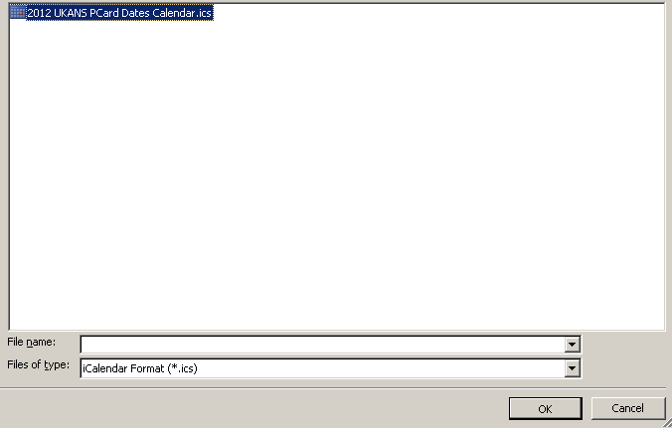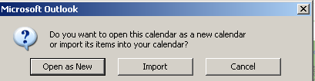

2

**Step**

**Action**

4.

Locate the saved file and click *“Ok.”*

5.

Select *Import.* Importing the calendar dates is now complete.