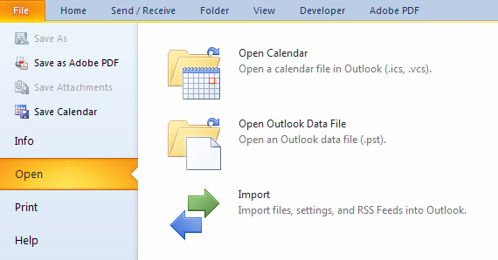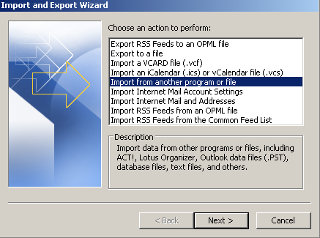

**Importing a Calendar from .csv File**

1

**Step**

**Action**

1.

Right-click file name and save as .csv file to Desktop or other location.

2.

In Outlook, go to File→Open→Import. The Import and Export Wizard will appear.

3.

In the Import and Export Wizard, select *Import from another program or file*. Click “*Next.”*

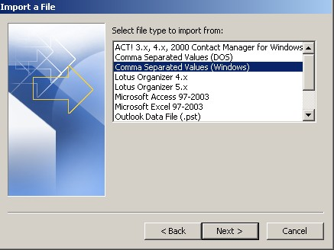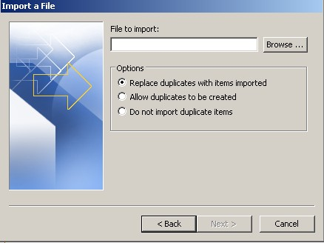

2

**Step**

**Action**

4.

Select *“Comma Separated Values (Windows)”*and click *“Next.”*

5.

Click “*Browse*” and locate the file that was saved in Step 1. It may be helpful to have the option *“Replace duplicates with items imported selected”* if the file is imported more than once.

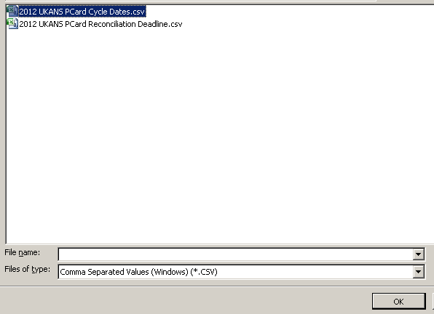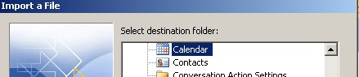

3

**Step**

**Action**

6.

Locate the saved file and click *“Ok.”*

7.

Select *“Calendar”* as the destination.

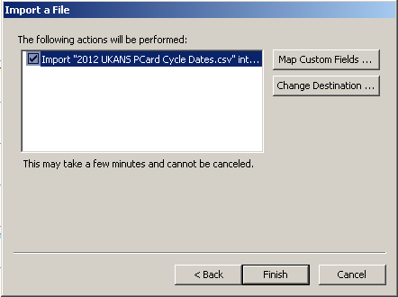

4

**Step**

**Action**

8.

Click *“Finish.”*